KIUYH In consideration of what exists. 11 12 13
Photography and Plans as existing of the site and Building at 13 Harbour Road
Inverness IV1 1SY
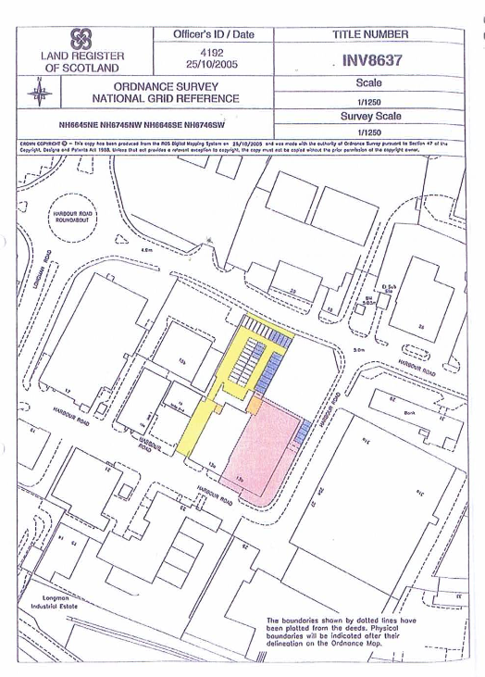

Entry level / Ground Floor Plan as existing with notes on usage .
Not to scale 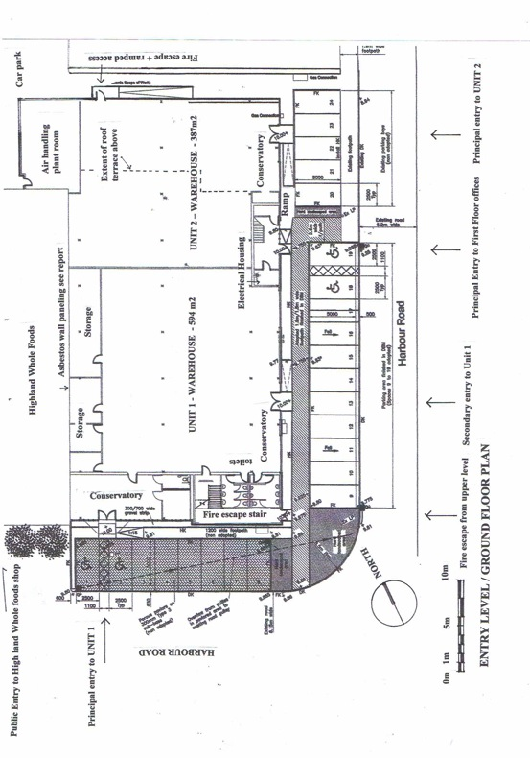

Upper level / First Floor Plan as existing with notes on usage .
Not to scale

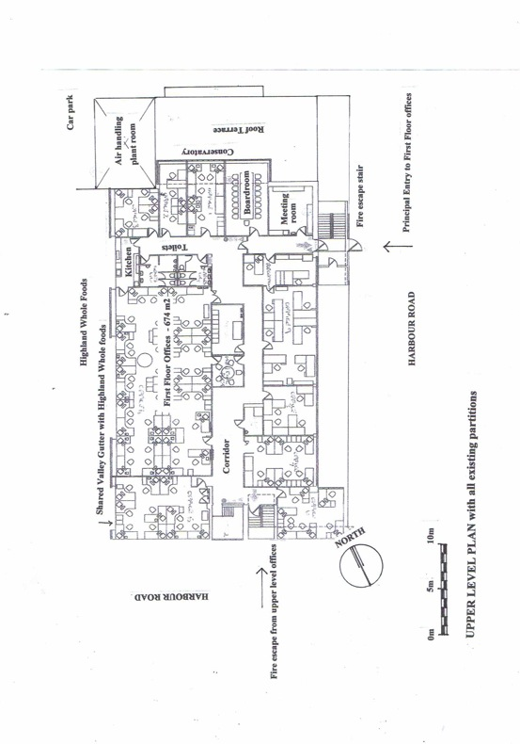

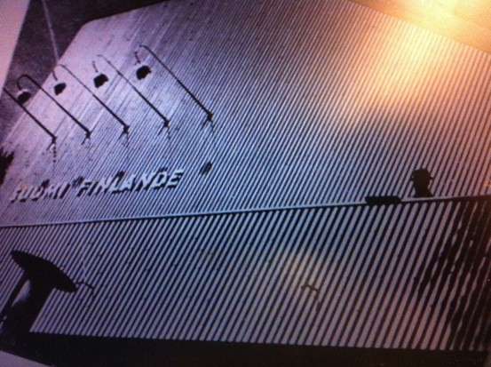
Looking for North

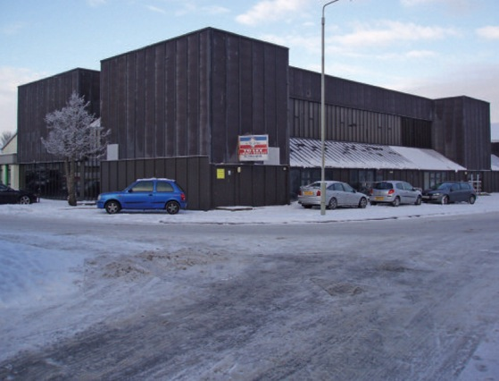
View of proposed KIUYH HQ Building from South

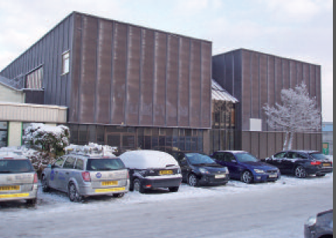
View from South west toward principal Entry to Unit 1

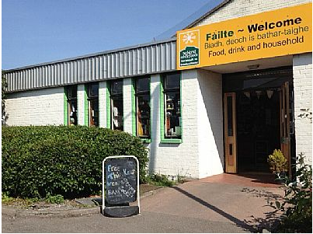
Immediate neighbor and adjacent Entry to 13 Harbour Road- Highland Whole foods
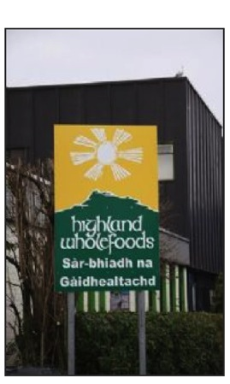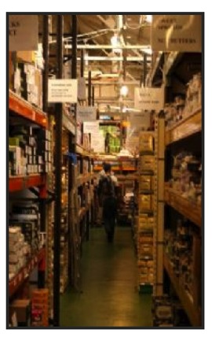
How Highland Whole Foods presently Existing customers, Ethics + no frills
presents itself .
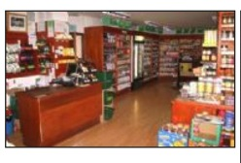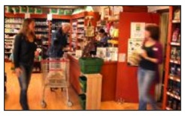
The shop that draws people because of what it is + who runs it

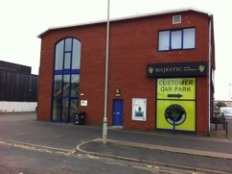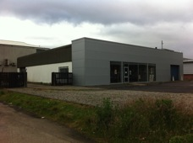
Other neighbors – Majestic Wines Ware houses + renewables abide.
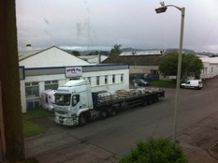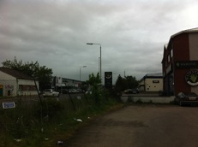
Simply Pets RBS offices

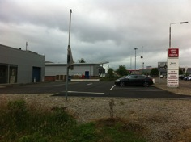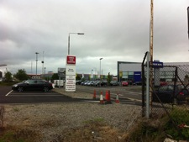
Car sales
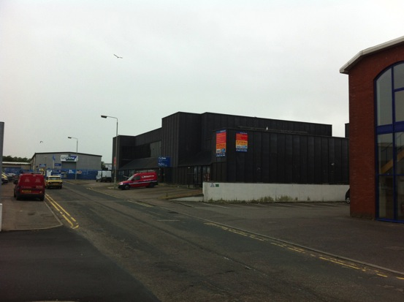
Harbour Road looking From North East toward proposed KIUYH HQ - No 13

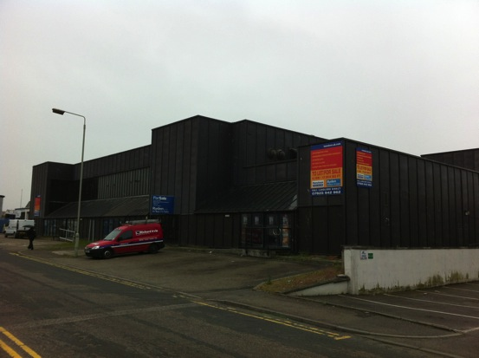
View from North East Showing Entry to Unit 2 with Roof Terrace above
View from North East showing Entry to Unit 2 with Roof Terrace above

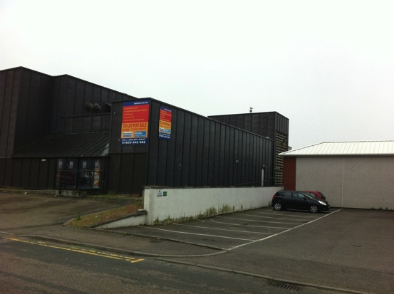

View From North East to Entry to unit 2 , ramped access , passage way to car park, Louvred Plant Room Tower and upper Terrace

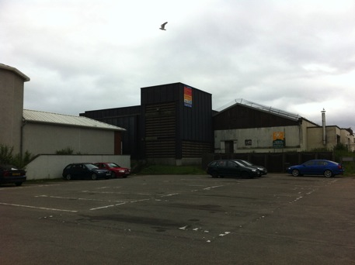
View From North West across Car Park shared with Highland Whole Foods toward Louvre’d Plant Room Tower of 13 Harbour Road and back door from Highland Whole Foods 17 designated spaces available for 13 Harbour Road in this Car park
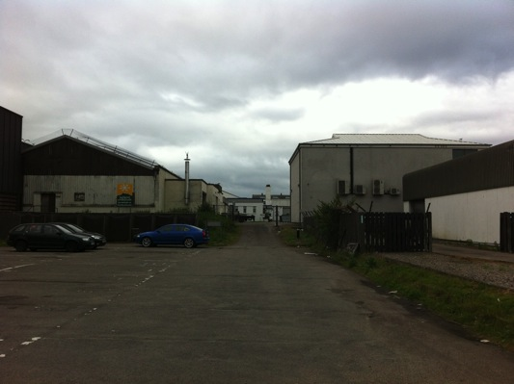Car Park and shared through way back to Harbour Road parallel to
Highland Whole Foods
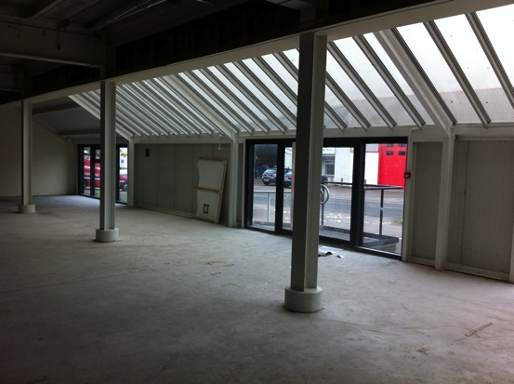
Inside Unit 1 looking to Harbour Road

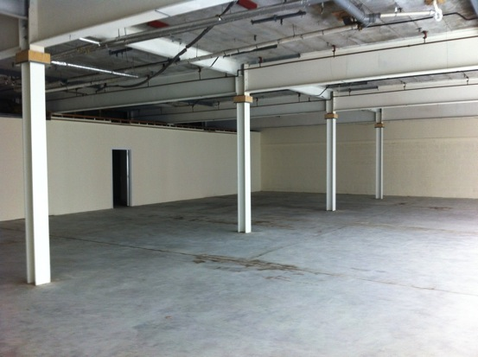
Inside Unit 1 Looking toward Party wall shared with Highland Whole foods

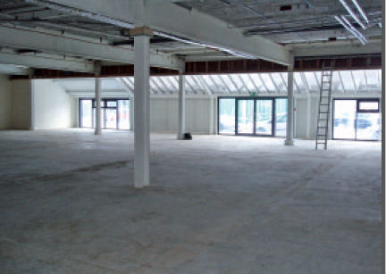
Inside Unit 1 Looking toward Harbour Road
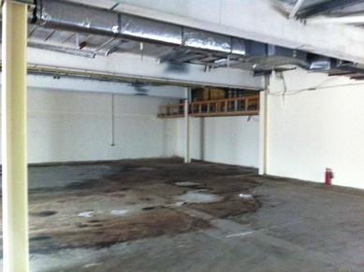
Inside Unit 2
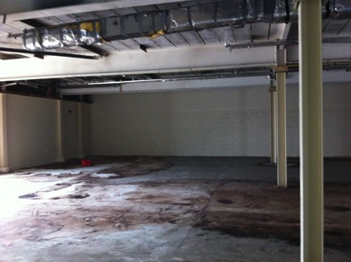
Inside Unit2
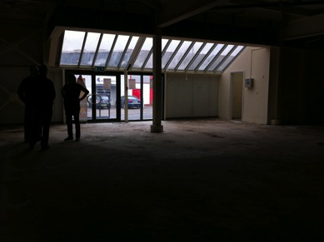
Inside Unit 2 Looking Out through Conservatory
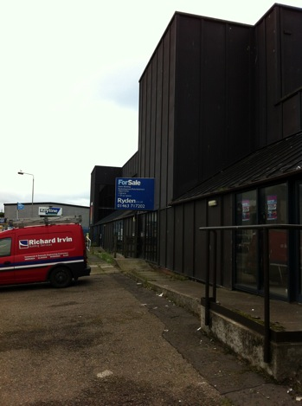
Ramp from Fire exit from Unit 2 winds past entry to Unit 2
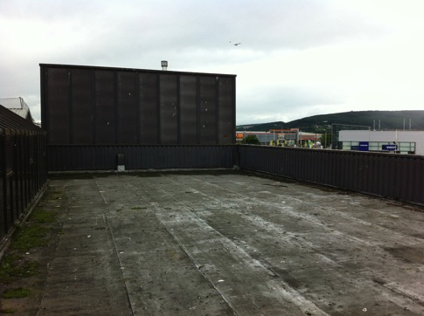
Roof terrace orientated toward North East is sheleterd from Prevailing wind
and deep enough to avoid shading. This provides access to main roof via
ladder only at the moement.
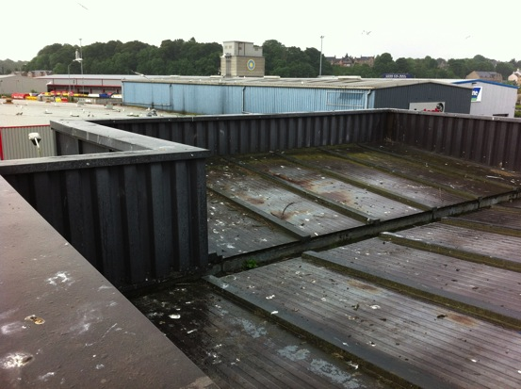
Dual pitch of main roof falls to valley shared with monopitch over Corner Tower
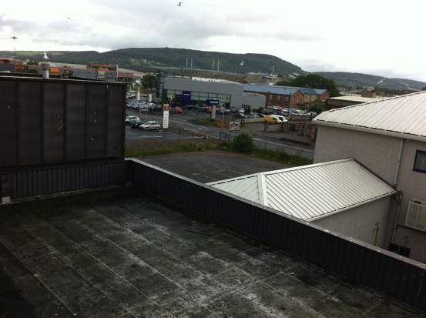
View down from Main roof over Terrace facing North East

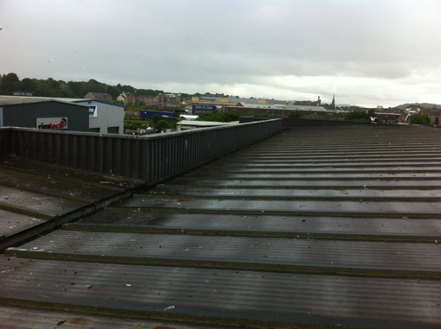
Main roof Falling to Valley Gutter and Parapet.

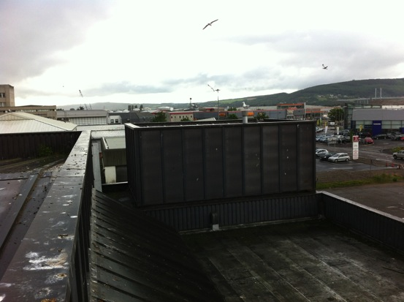
Parapet between Main roof and terrace with Upper Conservatory showing.
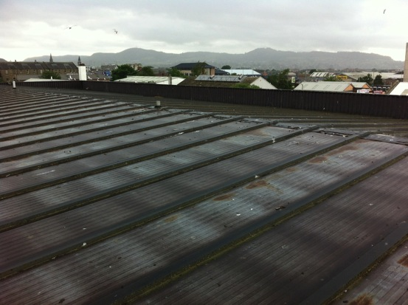
Main Dual pitch roof

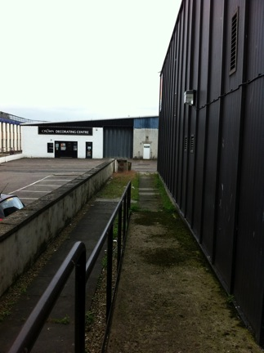
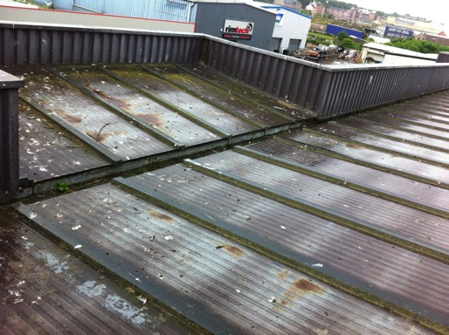
Typical Roof to Parapet
Ramp from Fire exit in Unit 2
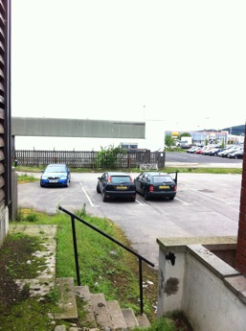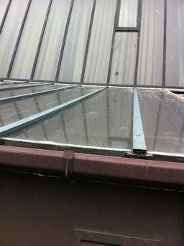
Steps Down from Plant Room to car Vertical Galzing to Pitched Glazing
Park

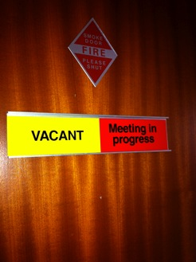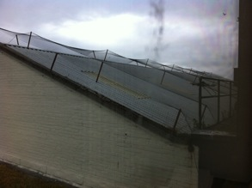
Fire Door to Board Room Valley shared with Highland Whole Foods

Miscelaneous details – Sedum Roof over HI HO shop – Many outmoded air handling plant . Downstirs toilets 3 phase Electrical Housing . Composite Panels + Cover strips.
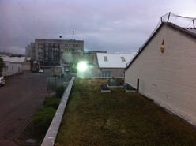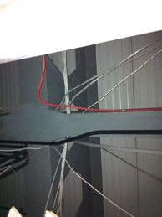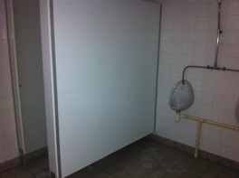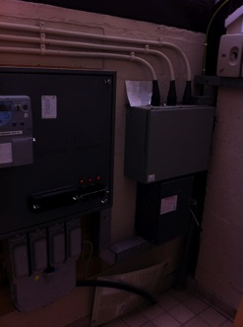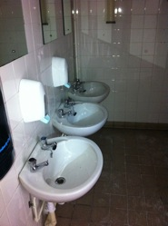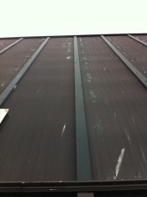

The route to 13 Harbour Road from the Railway Station

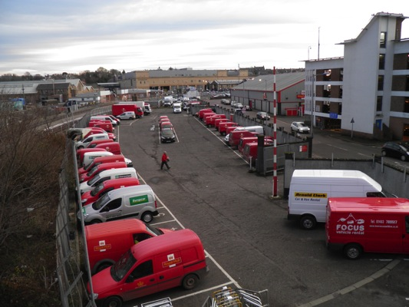
A walk parallel to the principal parking for the Railway station

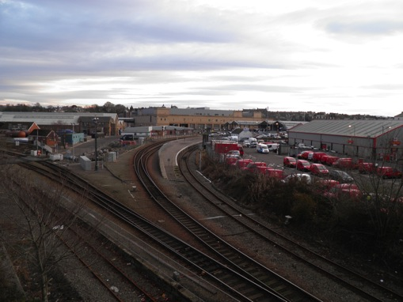
Looking back over the railway line you wonder of there is another flush route to Harbour Road available – New Pedestrian Bridge in the future through the goods yards ?
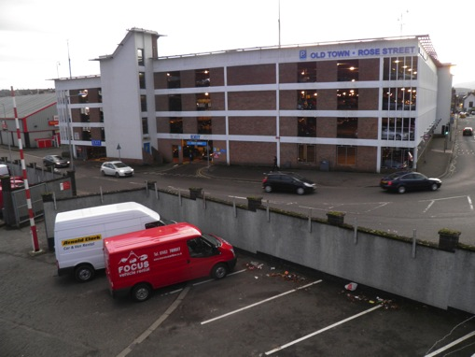
The principal Car park for Inverness Town Centre sit half way betwixt the station and Harbour Road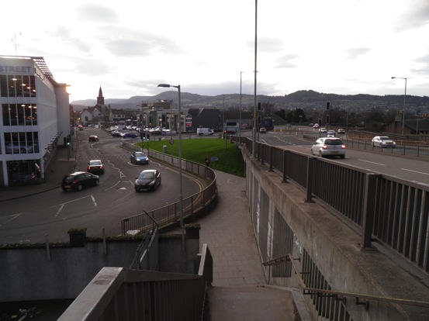
Ascending Up onto the Railway bridge to the A 82
Problem for Elderly Disabled and Cyclists
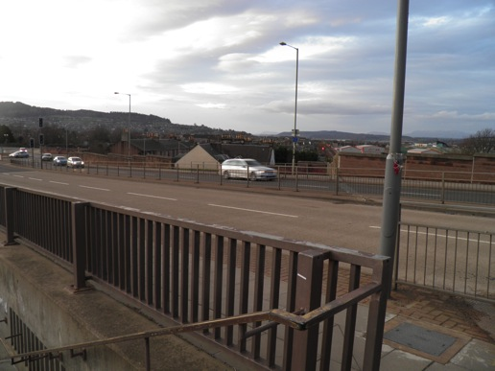
The A82 and the path to Inverness College , the bakery, Long man and Harbour
Road
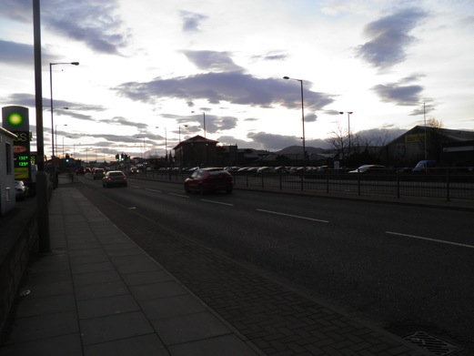
The A 82 and traffic from Kessock Bridge heading to Town.

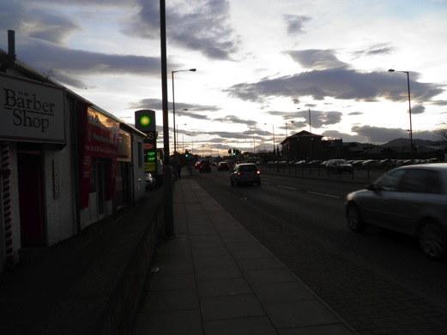
Further along A82 you turn on to Harbour Road – Traffic is heavy and you
yearn to be off this road .

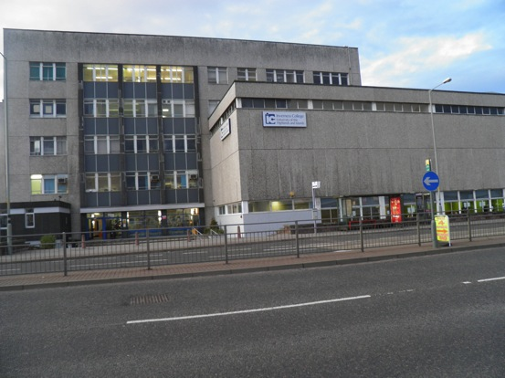

Inverness College due for replacement overlooking A82 ?
This will be a major cycling artery in the future .
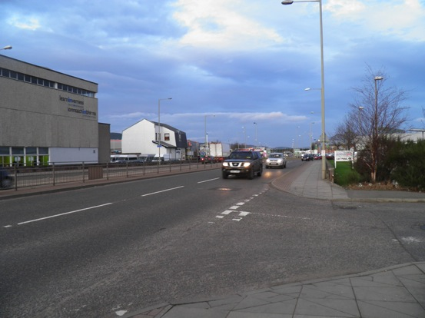
Looking North up the A82 and the turn into Harbour Road

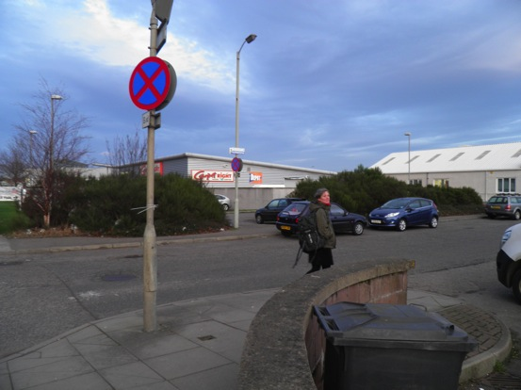

The turn into Harbour Road and Highland Whole Foods in white.. Calm returns …….
