KIUYH @ 11 12 13
Report – By Architect Andrew McAvoy RIAS

STEP 1 - FEASIBILITY REPORT
This report has been based on the following: -

(1)The organizations constitution which states that the aims and objectives

are as follows …
“The aim of the organisation shall be to establish a multi-cultural community cooperative business, for the benefit of the community in Inverness and the surrounding area, and to provide a forum for all those who wish to engage with that process.”
Section A - Preliminary observations on the evolution of this.

( 2 ) The following Timeline: - Starting January 2013

Scoping, organization and consideration was already substantial at the time of my first hearing about KIUYH.
Andrew McAvoy ( AM) , bumps into Karen Fenton and mentions the Albert Drive Project and emerging mobile Community engagement Tools .
Aha …Karen pulls the constitution out from under her hat and remarks…
“Community engagement … that’s what KIUYH is about. Maybe you help us develop our thinking …our business plan and help to assess the suitability of buildings we are considering ?” Answer yes.

Andy has been responsible for helping set up a number of formative organisations with low cost High quality infrastructure – Castaway 2000, Cove Park, Stornoway Trust. He has worked throughout in the highlands and Islands since setting up his own practice in 1999.
His own recent work in practice in 2013 included: -

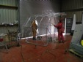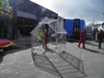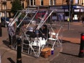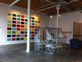

Albert Drive Project – The Mobile Tea Caddy House with Glas(S) Performance.

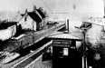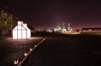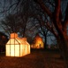
Ghost of Water Row – Govan – A Heritage and Community project.
Winning RIAS award for Architecture June 2013

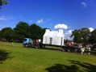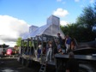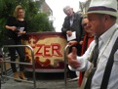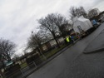
HLF funded “Fair Glasgow” mobile dialogue box on the road round the Summer Fairs and winter Schools to raise awareness of community and heritage under threat.
Completed March 2014 and submitted to HLF.

These small experimental projects have led to involvement in the world of KIUYH.

Discussions over the brief for the HQ of this emerging CO OP have listed the following functions.
- Co-operative Hub where the business of the CO OP is discussed and maintained.
- Office facilities for the running of the premises.
- Renewable energy showroom and training laboratory
- A community Café where people using the Longman and the Town can congregate.
- A drop in Crèche for members, users of KIUYH facilities and visitors.
- Overspill Crèche for non-users of the building.
- Dance and performance space.
- Meeting rooms for hire.
- Pop up restaurant.
- Low cost artists studio space
- Projection space for Art House film
- Training laboratories for craft based artists.
- Co-operative shop.
- Gallery space for Hire
- All-purpose rent a cube.

7th – 25th June 2013 – Correspond, discuss and review the formative processes of KIUYH.

AM then undertakes the following process: -

Upload Rydens Sale schedule for 13 Harbour Road and review.
Read asbestos report and prepare for visit.
Review the existing plans.
Consider the buildings typology and expression relative to its constitution, emerging aims, objectives and the above uses.
Consider funding routes to develop KIUYH and find a building that fits.
Prepare answers to questions10 -14 “for us all” raised by Big Lottery in their “Investing In Ideas” Application Process.
Dismiss or proceed. Discuss consider circulate …
Proceed with preparation of Application to Big lottery.

27th June – Travel to Inverness and meet with Stephen Kelly. Look at cultural context of central Inverness and discuss what is happening where and what is not.

Discuss Co-operative structures and how they are functioning in Inverness.

Visit 13 Harbour Road with Karen Fenton, Stephen Kelly and a clerk of works.
28th June – File notes and thoughts, up load photos and continue dialogue with KIUYH
Initial Feasibility work complete and decision taken to proceed with application to Big Lottery.

Feasibility Checkpoint – Stop or move forward.

Answer KIUYH + AM – Move forward

Time line continued: -

Feasibility continues 1st – 7th July 2012 – Final prep of the Application with a break down of what needs tackled to truly assess Feasibility of this “Big Idea” and we wait.
Architects Part is to be 50% of the task and to cover the following: -
As approved by Big Lottery.

“(b) The other main focus of KIUYH is, of course, the building.
50% of the funding would be spent on ensuring the above outcomes are deliverable in the way of infrastructure.
The building though perfectly positioned and espacially sufficient is a shell that is undoubtedly not functioning very well and needs a great deal of refurbishment to make it functional and visionary.
The visioning of how it will be brought up to an aspirational standard is critical in assessing the feasibility so as part of the Investing in Ideas we will commission the following.
STEP 1 - Initial visit and report by – Edo Architecture, and their chosen Structural Engineer, renewables expert + Quantity Surveyor. NOTE – This stage report.
STEP 2 - An initial sketch scheme of how the Building might be used would then be produced and on the basis of that then and only then: -
STEP 3 – A detailed report on the suitability of the Building for its proposed use would be completed based on some early visioning (Sketch Scheme).
With these tasks completed KIUYH would be able to hone their vision and complete their Business Plan to enable them to take the Project to Investors and Funders.
KIUYH scoping and broadening continue: –
Attendances by members at Bella drum Tartan Heart Festival Advertising and circulation via social media. Build awareness of KIUYH over the summer and autumn.

Work following the Initial Site visit: -

List suggested checks and measures to assess feasibility via the “ investing in ideas’
Award.

AUGUST 2013 – Big Lottery notify KIUYH of success of Application.
September 2013 – KIUYH discuss requirements for tendering the Feasibility work and decide that familiarisation time has already been expended by KIUYH and AM.
Check with Big Lottery. “Ok to proceed with who we have been working with already “ ?
Big Lottery say yes, though next stage will require tenders if feasibility suggests moving to next stage.
November 2013 – KIUYH appoint AM to commence the Feasibility work approved by Big Lottery.
December 2013 – AM makes a further visit to 13 Harbour Road to enable commencement of the work. AM also presents some conceptual design ideas about strategy and phasing and scale, to KIUYH.

11th December. With Harbour Road in mind AM gave the following Power Point presentation: -

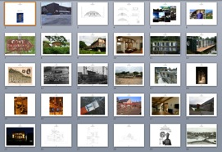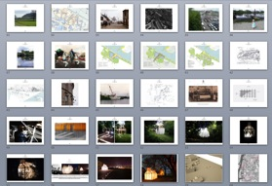

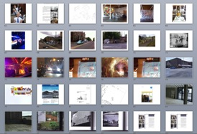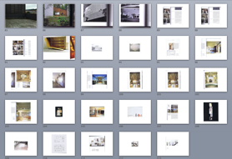

STEP 1 – Initial Feasibility report.

The Site visits and all above process has enabled the suitability of 13 Harbor Road to be judged against the following assessment criteria.

- History of the site
- Location and relation to: - Pedestrian flow from town, cyclists, trains, buses and parking.
- Its relation to a street pattern and useable outdoor space.
- Relation to other buildings, support functions, user groups and future users.
- Its very nature and ability to invite and engage.
- Its materiality and how it will sit over say a 25-year occupation and hold its own with some identity and status.
- Specific aspects of its fabric. Structural system, floors, walls, glazing, roofs, drainage, partitions etc.

ASSESSMENT OF POTENTIAL HEADQUARTERS FOR KIUYH

Existing redundant Building - 13 Harbour Road Inverness IV1 1SY

1 - History of the site

The Longman “Industrial estate “ has its own sense of identity and spirit of place.

That spirit of place or “genus loci” surrounds commerce and it always has.

At one time flooded and adjacent to harboring boats its nature was more ...maritime.

It is now a defined commercial Island within which many things happen. Its watery edges now those of roads and rail. However unlike most Industrial estates on the” out of town model”, this one is part of the town.

It could then; be viewed as a commercial archipelago, and one very close to the center of town. It is from all angles and approaches desiring of better linkages to enforce that.

There now follows a brief History check, to see why it has that genus loci and why it exists.

Time line of the Longman ----Tidal Flood zone or wetland with Neolithic remains, a burial site for a mythological Long Man figure (30 Feet), reclaimed land where the sea is locked out by embankment, Long Boat harbor, drained field, Gallows, Animal Market, Travellers park, Showground, Golf course, Aerodrome.

Finally defined and zoned in the 1950s as an Industrial estate.

It's vehicular nature, commerce and business are then…. long established.

The constitution of KIUYH appears to sit very comfortably with the history of this site. It's a place where pioneering new layers of inhabitation keep happening.

Some images of the Longman archipelago below, taken from the Website - http://www.ambaile.org.uk/en/

Also See Appendix A - Historic Map study by A McAvoy

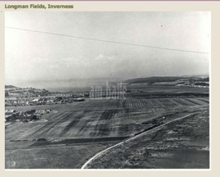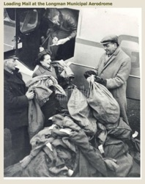

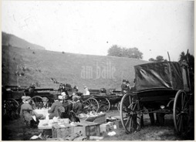

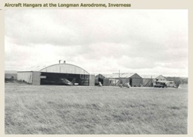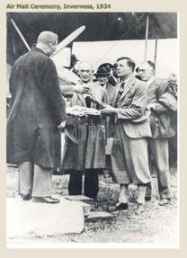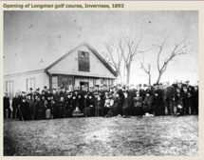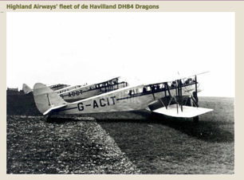

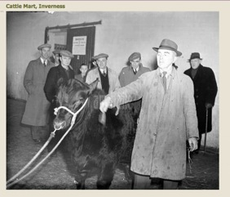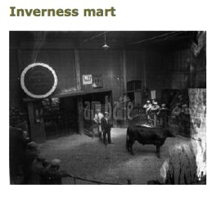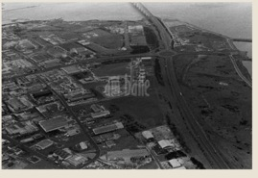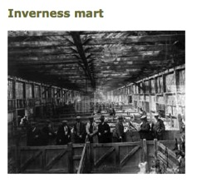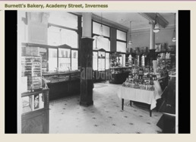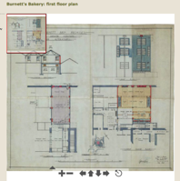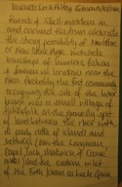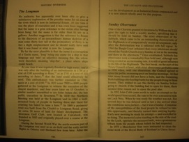

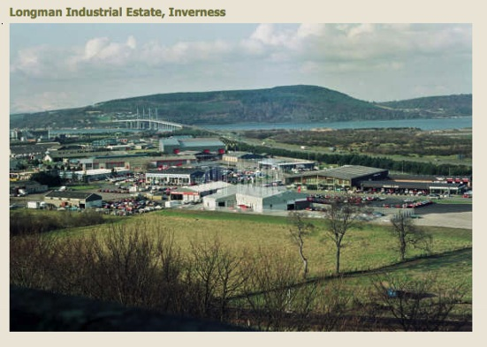

2 - Location and relation to: - Pedestrian flow from Town, Cyclists, Trains, buses and parking.

The Longman is busy: it seems quite lively and gives a sense of having always been a market place. It has tinges still of fairground, showground, market place, fabrication yard and on its watery fringes … boat yard.

A place betwixt water and fortified town on a small Hill.
A place with its own identity. A territory enforced by the railway line and faster roads that define it. Its raison D’etre or reason for being surrounds commerce.

It is an Island within which many things happen.

But an Island or archipelago very close to the center of town.

A quick History check to see why it has that unearths the following…

A Time line predating KIUYH, of the Long Man would include: - A Tidal Flood zone or wetland with Neolithic remains, a burial site for a mythological long man figure, reclaimed land where the sea is locked out, Long Boat harbor, drained field, Gallows, Animal Market, Travellers park, Showground, golf course, aerodrome.

Finally defined and zoned in the 1950s; with the advent of Planning, as an Industrial estate.

It's vehicular nature; commerce and business are then long established.

It’s now a place of transience that yearns further Commerce whilst requiring places of considered repose.
Its not a sit around and drink Coffee kind of place, it’s a place of errands.
Yet curiously …people sit in their cars and drink carry out coffee.

It’s the place you go to acquire things.
You come in from the hinterland, you buy materials to renovate your house, and you buy furniture, cars and update your appliances.
Typically you come in from the croft and you fill the boot of your car at Highland Wholefoods on a monthly or bi monthly basis.
In conjunction with that, having driven in from the hinterland - you leave the car and you wander into town. You take for some time the civic.
The Longman Industrial Estates symbiotic relationship to the town is sensed instantly.

It’s crying out for more reasons to visit and it could definitely do with a place for a culinary pit stop.

Its requesting better pedestrian flow to the town and distance betwixt cars and pedestrians and bikes

It’s asking for its layers of History to be teased out and some sense of its ancient worth to be re-established. Where did Seafield House go?

Most dramatically though given its importance in the development of commerce in Inverness it is not celebrated for that Commerce.

The landscaping is generally about cars and lorries. It facilitates too much parking. It's a loop of a road that helps about turns, turning, parking.
The excitement and bustle from a human perspective surrounds the energy and logistics required to move from one large retail environment to another.
As you walk from the town and railway station to the Longman you are easily lost.
It does not flow easily and you have to be in the know, or be confused by signage. You are not presently easily orientated toward it.
Though the train station sends you merrily in that direction. It is not as salubrious of its function as it should be …. As it could be.
You have to climb a steep stair up on to the railway bridge.
When you have been once its easily retraceable.
That important route that would bring anyone to KIUYH requires careful consideration. It would at least, require landscape upgrade and signage for ease of passage.
The trundle out of the station via Platform 1 suggests the route and sends you… Yet it quickly deteriorates.
For anyone physically impaired or someone with a bicycle, there would have to be improved ramp access up on to the railway bridge, or a new route that removes the steps and cars and kerbs.
Once up on the bridge and elevated …thereafter it’s easy. It raises the immediate question of … Can a new route be created for bikes and pedestrians from the railway station to KIUYH HQ?
From Railway Station to Harbour Road …It’s presently a 10 minute walk of 1 km
5 minutes of that are unpleasant as road traffic on the A82 is heavy and fast.
Upon leaving a Train and arriving in Inverness; taking to your feet to attend KIUYH, there will be anticipation of a pleasant journey. With that anticipation will come a yearning to be distant from so many cars and HGVS, rat running through the town.
What KIUYH solves …the Longman, the college and the bakery will benefit from.

3 - Relation of the proposed facility to a street pattern and useable outdoor space.
Harbour Road is utilitarian by Nature.
Little defended, protected or elaborated people space exists.
Highland whole foods is a sanctuary.
In a highland town kind of way, nothing is particularly well maintained: - The street furniture is shabby, the pavement a mess and not celebrated as surface. It’s not civic in any way. Blink and compare it to a small provincial French town or a Scandinavian one. What happened? Where did all the care go? Commerce has been left to run amock. The economy is leaking.

You don’t find street furniture for pause. There is no tree cover to slow down the wind speed or provide summer shade.

You wonder how a central European visitor will view this…..on their way to visit an internationally renowned Artist in the new KIUYH HQ. How will they?

Is this is a City for people or just a city for cars and commercial interests?
Are there ways to soften this up and create more people friendly space?
Yes there are.

This is the city; this is life, as its lived and each precious sq. meter remains an opportunity.
Longman is a meeting place: its just not one that's being celebrated as such.
As a trading estate, it is defaulting to basic function and no more.
In the absence of gentle surface and places of repose and pause, chance happening is left to deal with expectation.
Wonderfully and frustratingly in equal measure the highland attitude of make do, turns walls into furniture.
Cars rule the roost and gulls the size of pterodactyls command the air.
It tends to drive you indoors.
The Cessock hills disappear beyond the roofline and you have little sense of where you are geographically.
Due to this having been a low-lying Seafield, terra firma sits low relative to the wider landscape. You go down into the Longman estate….
There is therefor some yearning to ascend up and take back the landscape as your own.

4 - Relation to other buildings, support functions, user groups and future users.

Inverness is booming. There is; by all accounts, no space for new functions and the population is soaring.

The streetscape shows little sign of that. I think of Bergen and heated pavements

Shelter, wind breaks, blankets on terraces etc.

Rather than the plot. the lot and developable areas should we not be putting buildings in relations to weather ?

Highland Wholefoods ( HI HO ) thrives, welcomes and sustains so many. However it in no way represents the full plethora of hope of the community

That it supports.

HI HO requires allies, brothers in arms to tackle civic decay. Its wonderful Co –operative ethos is not spilling put into the locality. In an away it’s hiding from the realities of that.

Being back to back with HI HO … Yes… It’s a major draw for KIUYH.

Side to side they could work very well together and reverse some of the Civic decline that’s showing in the Longman.

Motives are shared – better health and well-being, sustainability, space for kids, places of repose, care for the environment.

Being back to back the principals of considered cooperative trading could be shared.

One enforcing the other in developing bottom up approaches to cultural planning.

Neighboring major institutions like the Old Baker and the Highland College are run down and due for replacement. They are then, future custom and KIUYH is mindful of this.
Were KIUYH HQ in place they would trade services and functions.
KIUYH could serve them well – They are part of the demographic and to be monitored.
The Longman has a reputation for servicing commerce and therefore has established trade. HI Ho is growing and will long provide passing trade.
The Building in question at 13 Harbour Road, stands amid many harlled metal and corrugated sheds that: do not so much invite, as hold a sign up identifying their use.
Familiarity of users prevails where more facilitation of natural human enquiry would increase use.
Diversity in use is therefor also depleted.
Associations and expectations are left to chance and repeat behavior.
Behavior then: whether it be sustainable or not, becomes habitual.
Cars are everywhere and dominate the street scene.
The steps up into Highland whole foods and the sense of color and warmth of the interior of the shop draw you in. Presently however someone has had to introduce you or take you there. Signage has to be bold and directed.

To some degree the delights of the Longman remain specialised and concealed.

A series of small secretive sub sects of society for those who already know.

The Hi HO Shop entry is shared in streetscape terms with that of the proposed HQ for KIUYH. In assessing how KIUYH will work its necessary to consider how that is working and used presently.
The main Car parks for both are shared at the rear of the Buildings.
The same pedestrians, cyclists, train users, bus users and car drivers will use KIUYH New user groups will be the same.
So there exists already - some sense of an entry to 13 Harbour Road on its
For now though at no 13 - the shutters are down and nobody is home.

5 – The very nature of 13 Harbour Road and its ability to invite and engage.

A building either invites or does not.

This one has some presence due to its massing and as such it is prominent.

It sits in a positive relationship to Harbour road: in that, it is set back enough to provide drop off and gathering space adjacent to its entries.

Importantly there is space, for further celebrating entry and for creating positive useable outdoors space.

Presently hard standing and tarmac take all of the space up and cars slide up close to the building. Only leaving a pathway round its edge.

The tenure of the building and its curtilage suggest taking space back.

A need exists to create space, which anticipates the change in use, Future plans must allow for emerging requirements for external green space, terrace and garden.

The building speaks quite proudly as some Scandinavian buildings can.
It is a building of the Northern hemisphere.
It is an Industrial building without decoration.
A machine made for working, now redundant.
In assessing its expression you ask… does it speak for what it was made for.
An Electronics factory? Yes it does.
Does it provide a suitable building block or blank enough canvas onto?
Which the Brief of KIUYH could be layered? Yes it does.

There is presently no existing warmth or welcome on show,
Will that be possible? Yes.
The balance of solid to void via glass and the buildings position relative to entry and sunshine suggest that it is convertible. Is it easily convertible via its existing
Structural system and layout. Yes.
Can it become: via inexpensive and simple reworking a Beacon
That draws people toward it? Yes.
What message does it convey presently?
It requests occupation. Warmth and inhabitation.
It does no one good to have this sitting there like that.

Could it become a very positive addition to its neighborhood? Yes
Is there potential for bad neighbor issues No

Observations

KIUYH, a formative organization have found it and aspire to it. In these times that is worth a lot, to the building and the environment.
It could be a vital organ in a body of existing activity that could turn the tide of decay and nonchalance that the Longman is experiencing.
The corrugated panels in dark bronze finish stand out as uniform in a landscape of signage and little restraint. … It is therefor, quite noble by its restraint… in one color and its repetitive nature.
It says I am speaking for robust northern Culture, against the weather and for productivity.
It seems very contemporary and actually quite dignified in its reserved expression.
Its simplicity is its primary strength.
The building welcomes through being rigorous.
It gives a good first impression.

Is it worthy of this proposed use? Yes

- Its materiality and how it will sit over say a 25-year occupation and hold its own with some identity and status.

As the surveyors see it.

The subject property is prominently positioned on an offshoot of
Harbour Road within the prime Longman business area of
Inverness. This off shoot forms a loop effectively bypassing the
Main Harbour Road/ Longman Road roundabout connecting
Harbour Road onto Longman Road directly opposite Inverness
College and close to Northern Constabulary's HQ. Harbour Road
Is a key arterial route running from Inverness Harbour at its
Western end, crossing the A82 Trunk Road (Longman Road)
close to the subject property and then linking onto Millburn Road
at its Eastern end.
The Longman area is recognised as the prime business location
Within Inverness and is a key service center for the Highlands. It
benefits from excellent road links with direct access to the A9
heading North to Wick and South to Perth, the A96 heading East
to Elgin and Aberdeen and the A82 heading West to Fort William.
Inverness city center is approximately 0.25 miles to the South
West and is within easy walking distance giving access to the
Railway and Bus stations, city center shops and amenities. Key
surrounding occupiers include Inverness College, Majestic wine
warehouse, Keyline Builders merchants, Calterdon/ BMW and

Eagle Consulting.
DESCRIPTION
The subject property is a prominent 2-story Production facility
with 33 dedicated car parking spaces. It can accommodate a
flexible range of uses including production, general storage,
trade counter/ showroom or offices. It may also be suitable for
leisure or retail use, subject to securing the necessary planning
consent.
The subjects provide office accommodation at first floor level with
access from a secure entrance on the side elevation via a
stairwell. The ground floor provides two separate trade counter/
showroom, storage or office units each with their own separate
access doors. Unit 1 benefits from male and female toilets as well
as a separate reception/ front office. Both units have been
finished to a shell standard with 3 phase electricity and gas

supply. They could be combined if required.

FLOOR AREAS

We have measured the property on a gross Internal basis and
calculate the floor areas to be;

UNIT 1 – 594 m2 ( 6 394ft2)
UNIT 2 – 387 m2 (4 166 ft2)
First Floor Office – 674 m2 (7 260 ft2)
Total 1 - 665 m2 GIA (17 814 ft2)

Units 1 and 2 have a clear eaves height of 3.15m

The first floor offices have a Net Internal Area (NIA) of 313m2

Presently The facility offers 33 Car Parking spaces

6 - Materiality Continued

This building was built as a small component electronics factory; it was built to be functional. It was built to accommodate many people.

Ground Floor – Unit s 1 + 2 were warehousing

First Floor – Office indicated a seating layout for 80 People.

Consequently it was well serviced with Fire escapes and toilet facilities.

It was quite robustly built and has on initial inspection a good degree of life left in it.
The Foyer to Unit 1 is effectively via a suitably solar effective Conservatory.
No draft lobby is provided to this. From that foyer you enter the largest space in the building with a series of rooms servicing it.
Presently no stair exists to allow passage upstairs from Unit 1
At closer proximity the entry door is rather abrupt – No lobby you are suddenly in with a key…. from a howling wind. When the doors open the wind goes in with you and all the heat of the conservatory is out.

It suggests a porch – a dress down and shakes it off space that is not presently there.
Layering up external shelter and lobby space is suggested.
Will that be simple to achieve? Yes

Future use, Planning and Development Control
It is understood the property has existing planning for use
Classes 4 (Business), class 5 (General Industrial) and class 6
(Storage & Distribution). Under the proposed new Highland Wide
Local Development plan the property is located within the
Longman Core where the council will also support the
development of office, leisure, service or retail uses subject to
certain conditions.

Check – Does the remit of KIUYH fit this description Yes

7 - Specific aspects of its fabric. Floors, Supporting Structure, Walls, Glazing, Roofs, Drainage etc.

In analyzing the building and developing proposals for it compliance with the modern standards will be paramount.

This feasibility study though not able tackle technical intricacies of the building will give consideration to the following :-

The Building (Scotland) Act 2003 gives Scottish Ministers the power to make
building regulations to:
•Secure the health, safety, welfare and convenience of persons in or about
Buildings and of others who may be affected by buildings or matters connected
With buildings
•Further the conservation of fuel and power and
•Further the achievement of sustainable development.
This document gives guidance on how to comply with these regulations

The building standards system
The building regulations are enforced through the building standards system
that is established by the Building (Scotland) Act 2003. The Act sets out the
enabling powers that allow the Scottish Ministers to make, not only the building
regulations, but also procedural regulations, fees regulations and the other
supporting legislation needed to operate the system. The system is designed to
ensure that new buildings and works achieve the objectives of the Act in terms
of health, safety, welfare, convenience, conservation of fuel and power, and
sustainable development.

Section 1 Structure (EC - Mechanical resistance and stability)
Section 2 Fire (EC - Safety in case of fire)
Section 3 Environment (EC - Hygiene, health and the environment)
Section 4 Safety (EC - Safety and accessibility in use)
Section 5 Noise (EC - Protection against noise)
Section 6 Energy (EC - Energy, economy and heat retention
Section 7 Sustainability (EC – Sustainable use of natural resources)

FLOORS
The Ground floor is composed of a Concrete Slab
No visible signs of settlement or cracking
Visible signs of water staining. Each case to be investigated relative to surrounding fabric and technology.
All specification, insulation and thickness of Concrete slab to be ascertained from original Building Warrant. Where not available Engineer to open up and test sample Most importantly the Insulation standard requires resolve with requirements for any up grade.

Suspended first Floor in interlocking Concrete panels.

Ditto ground floor slab- specifically in relation to Fire protection, Sound transmission and structural integrity. Need to find original Warrant or,
“As Built “drawings on Highland Council Microfiche

In developing proposals for the reworking of the Building and the Cost plan, attention will be paid to the latest Scottish Building Standards + the associated Technical handbook – Non Domestic – Section 1 - 7

SUPPORTING STRUCTURE
The building consists of a series of large Mild Steel portal Frames with first floor Beams. Between these Frames Interlocking reinforced Concrete panel floor sections span steel frame to frame and support the upper level.
The steel is painted and exposed.
There are Requirements to check existing Intumescent paint status.
What was applied, when and its performance criteria need to be checked, as upper floor will have to retain integrity in a fire to allow for escape from the building.

In developing proposals for the reworking of the Building and the Cost plan, attention will be paid to the latest Scottish Building Standards + the associated Technical handbook – Non Domestic – Section 1 - 7

WALLS
The Steel Frame is clad with a twin composite Panel with an unknown amount of Insulation between the skins. It appears to be in reasonable order and could be repainted for the sake of longevity. However: -
It would seem prudent to assess this panel system. : - Who made it? What from, its longevity credentials, thermal performance, ability for refurbishment, moisture performance, possibilities for re sealing etc.
Partitions - All internal walls are In 4 x 2 timbers framing with plaster based board each side. All easily removed, reused, up cycled or passed on.

Engineering Check required? Yes

The external finish to the composite wall panel is holding up at the moment Check that it can be successfully supplemented with a new coating to prevent oxidization and decay of the metal.
Proposals could easily allow for the construction of a secondary self-supporting internal wall layer to meet a higher standard. Then leaving the existing composite as sacrificial. For instance layering it up with a 200mm x 50mm lightweight wooden frame internally with suitable insulation could bring the building up toward robust detailing and performance for the 21st Century.
The integrity of what exists requires study first of all.
Check – early 1980s building – Where is the Building Warrant – Microfiche with Highland council?
Search required.
In developing proposals for the reworking of the Building and the Cost plan, attention will be paid to the latest Scottish Building Standards + the associated Technical handbook – Non Domestic – Section 1 - 7

GLAZING
The aluminum window system is anodized to match Cladding – the seals on the double-glazing are failing in a percentage of the panels.
I wonder if each panel can be removed and resealed in a production like way …
The glass is not decaying, it’s the rubber.
One system is used throughout.
Sustainability recycling and up cycling all to be considered.
Glass is generally well orientated and should allow for substantial solar gain half of the year.
That system should be identified scrutinised and a refurbishment process investigated.
The System in place will no doubt fall short relative to latest Scottish Building standards Part however it could be upgraded in phases.

ROOFS
The roof is a corrugated insulated composite panel system. Its conducive with the age of the building in early 1980s – it has a dual pitch, draining to deep edge gutters hidden behind parapets. It seems in Reasonable order
It would seem prudent to assess this roof panel system, who made it, what from, its longevity credentials, thermal performance, ability for refurbishment, re sealing etc.
In developing proposals for the reworking of the Building and the Cost plan, attention will be paid to the latest Scottish Building Standards + the associated Technical handbook – Non Domestic – Section 1 - 7

DRAINAGE
Rainwater goods are concealed behind panels on corners, which require individual inspection and review.
Major observation - The integrity of what exists requires detailed study first of all.
Check – This is an early 1980s building – Where is the Building Warrant
Microfiche with Highland council or whomever built it.
The company …Whites Electronics?
Search required.
Connections to mains Sewer require Checking with Scottish water.
Is system up to date and performing?

In developing proposals for the reworking of the Building and the Cost plan, attention will be paid to the latest Scottish Building Standards + the associated Technical handbook – Non Domestic – Section 1 - 7

Sustainability, continued use of an existing building and phasing of the works to enable it to progress steadily will be key considerations.

The building cannot be completely refurbished in one straight phase, as it is very large relative to a small organization.

Once basic wind water tightness and Health and safety are achieved insuring the well being of the users - KIUYH would begin at the entry and work logically north from there in a compliant way solving and providing.

As occupation increases and budgets flow, another manageable chunk would be undertaken.

The idea of slotting useable functional finite pods into the larger framework has been muted and deemed fitting of the ethos.

13 Harbour Road then becomes a Citadel into which things are placed.

To Reference the up to date Technical Handbook :-

http://www.scotland.gov.uk/Resource/0043/00435261.pdf

A WALK OVER INSPECTION OVER 2 VISITS HAS HIGHLIGHTED THE FOLLOWING ( Practically and Experientially)

GROUND FLOOR AREA

The entire building is presently set up via the same large Steel Frame, column positions and spans. It could then be treated as one big open plan Building over two floors.

However the Ground floor is split into Unit 1 + Unit 2

Unit - 1

From the Southwesterly entry adjacent to the entry to HI HO and the nearest point to the town Centre. You enter a conservatory foyer.

From that Foyer you pass to a large uninterrupted Warehouse Space.
In what would be the front of house through to main gathering congregation and social space, the spans are huge and conducive to dance and performance.
Check performance data with KIUYH
Unit 2
Is of the same structural system as Unit 1 and works in a similar way to zone 1.
It has much less glazing and the effects of the deep plan are pronounced.
It is layered over above with the roof terrace and there are signs of water ingress.
Flat roof data requires checking.
Fire escape in back corner to ramp? Wheel chair friendly?
A more inclusive and compliant route for wheelchair and challenged users. ?

UPPER FLOOR AREA
The first floor Offices are presently accessed via their own door and stairwell.
They presently exist as an unnavigable warren designed on the basis of 80 - bums on seats and a long disorientating corridor flanked with Fire doors.
Its not clear if the present layout of partitions was original or in fact if it can comply with travel distances ? KIUYH already see most of the partitioning coming out and studio space being created in an innovative way … Reducing pressure and risk.
See Power Point AM to KIUYH of 11th December where the idea of moveable pods are created on demand.
Presently there are many internal rooms and none of the spaces work well. Other than the meeting and boardroom which have upper level conservatory space and access to the Terrace the upper floor plan might be opened without changing the structural integrity of the Building. Structural Engineer to check.

It’s a bright sunny conservatory in relation to a long garden, but it’s the back end of cars at the moment.
Ramps versus Lifts!

Some observations on the Building structure.
The building consists of a series of large portal Frames with first floor beams spanning. Interlocking reinforced Concrete panel floor sections span steel frame to frame and support the upper level. This system allows for easy reconfiguration of the plan and spaces defined by the building. Engineer check.
The building shares one long edge back to back with Highland Whole foods.
One long edge and one side are very public and where entries and presentation is key.
One short edge is presently allowing for flush exit via ramp and access to the facilities Car Park to the North.
Disabled Parking would have to be sustained in relation to Flush entry.

All internal walls are constructed from lightweight systems such as 4 x 2 Timber Framing with plaster based board each side.
Mainly easily removed. Engineer to confirm.
The building is deep in plan with much glazing to the approach elevations on the South Western entry and South Easterly long elevation.
These two Elevations have large areas of Conservatory, which will do much on many fronts: -
They invite advertise and turn the building into approachable Beacon in the long winters
They have the capacity to generate heat for the Building. And to work symbiotically with a ground source heat pump or similar. Heat Generated could then be easily distributed to the back areas away from the glass?
The Conservatories as front of house works well for this deep plan building.
The entries then interface well with the outside world.
Presently with special subdivision strictly separating up stairs and down stairs,
Natural daylight does not pass easily to the deep interiors.
The building would profit in day lighting terms from sharing direct sunlight as it moves round the building. Removing partitions and slapping holes in the first floor and working on the basis of an open plan would be wise generators for any proposals.

There is no existing circulation from Unit 1 to Unit 2 or to the upper level.
The main space of Unit 1 suggests a ramp up in the Northern most corners, with its start orientated toward the entry.

At Ground floor adjacent to Harbour Road- Both Units 1 + 2 have a 5 m parking zone that’s suggesting Terrace or garden free of cars. Some parking immediately adjacent to the building would have to be surrendered. Cycle racks would be encouraged. Electrical Vehicles might be encouraged. Could this be the site for Inverness’s first recharging point for electric cars? ?

Ground Floor Conservatory space
Good orientation.
Effective conservatories in relation to potentially symbiotic long gardens, but presently garden occupied by cars, which will need to be taken at least in part out of the equation. Demographic loading and local authority position to be checked.

Plant versus renewables
The building in its original use required State of the Art air extraction, for clean manufacture of electrical apparatus so the Air Handing plant required a large space over 2 floors. This Tower remains filled with the AC apparatus and provides an effective space for new eco tech
Presently functioning as Pigeon Loft due to Louvre’s.
What will occupy this space to serve this new use?

Upper Conservatory
Poor orientation for solar gain. Good studio or creative space.
Only access presently to upper Terrace.
Useful in gathering North Light but requires thought on Insulation seasonally
You leave the upper conservatory to take the substantial North-facing terrace.

The upper Terrace
Pterodactyls aside …it’s a relief! The roof scape of the Longman and glimpses of the historic town are yours. Suddenly the highland Landscape is yours again.
You are out and up of the flood plain.
Suddenly its all sky and you have secret citadel world of your own...
It is a major asset to the building, assuming its construction is working.
It’s a terrace from a far away culture not Inverness that could be a major draw for the facility. It suggests like the garden below that all spaces should focus on it and allow for passage to the out doors. Plan configurations to anticipate?

From the upper terrace you can take ladder access to the main Parapet Roof.

How will that be best achieved?
Upon inspection of the main roof of the building questions are raised about potential for a future other Floor. Every sq. meter on high in this location will be valuable.
Fire escape and structure require assessment.
Potentially there is another 300 Sq. meters of sky lab in the waiting.
Could the structure cope? Engineering question that could sort the business plan!

Cost Plan and Phasing ….to take this on as KIUYH HQ

FLOOR AREAS

We have measured the property on a gross Internal basis and
Calculate the floor areas to be: -

UNIT 1 – 594 m2 ( 6 394ft2)
UNIT 2 – 387 m2 (4 166 ft2)
First Floor Office – 674 m2 (7 260 ft2)
Total 1 - 665 m2 GIA (17 814 ft2)

Units 1 and 2 have a clear eaves height of 3.15m

The first floor offices have a Net Internal Area (NIA) of 313m2

Presently the facility offers 33 Car Parking spaces

KIUYH will purchase the Building and take full ownership of it.

Forecast Costs to purchase and run the facility: -]

1.0 - Cost to purchase.

Not being cash rich there will be annual loan payments on that outlay to meet.

Cost £ 400 000.00

Annual Cost to service that Borrowing ( 25 Years ) - £ 25 000.00 per annum

2.0 - KIUYH will be responsible for annual running Costs.

Maintenance £ 25 000.00

Heating light + Power + Servicing = £ 25 000.00 per annum

Subtotal - Cost guestimate - £ 50 000.00 per annum

3.0 The Building has a ratable value as follows and annual running Costs

will have to anticipate that.

Annual rate s Bill - £ 10 000.00

4.0 - Insurances - £ 5 000.00

5.0 - Staff - £ 25 000.00

6.0 Refurbishment

Taking at this time an average cost across the whole building of £1000.00 per Sq. meter would

I think allow for basic upgrade over time and reasonable standards to be met.

Gross Internal Floor Area of 665 Sq. meters x Refurbishment rate of £1000.00 = Construction Budget of £ 665 000.00

Associated development Costs to enable a number of building Professionals and consultants to undertake the work to enable that would require 15% over and above that figure.

15% x £ 665 000.00 = £ 99 750.00

Development Costs for refurbishment

£ 665 000.00 + £ 99 750.00 = £ 764 750.00

Annual Cost to service that Borrowing ( 25 Years ) - £ 50 000.00

The monthly outgoings to have a functioning HQ at 13 Harbour Road

Without the introduction of Capitol by the shareholders in KIUYH

Might then be the totals of these Annual Costs - £ 165 000.00 per Annum

Borrowing, funding phasing then having to be offset against the ability to bring money in.

See forecast Income data prepared by KIUYH based on the following emerging Accommodation Brief.
A McAvoy – Dated - 11 12 13

Discussions over the brief for the HQ of this emerging CO OP have listed the following functions and each of these will raise potential Annual Income.

- Co-operative Hub where the business of the CO OP is discussed and maintained.
- Office facilities for the running of the premises.
- Renewable energy showroom and training laboratory
- A community Café where people using the Longman and the Town can congregate.
- A drop in Crèche for members, users of KIUYH facilities and visitors.
- Overspill Crèche for non-users of the building.
- Dance and performance space.
- Meeting rooms for hire.
- Pop up restaurant.
- Low cost artists studio space
- Projection space for Art House film
- Training laboratories for craft based artists.
- Co-operative shop.
- Gallery space for Hire
- All-purpose rent a cube.
- Parking revenue
- Cycle Hub and maintenance shop.
- Education facilities feeding Curriculum for Excellence.

The Co-operative strategy of shares and introduced capitol currently being investigated will be developed to reduce the monthly outgoings.
Over time the annual bills would come down and the Income will increase.

Investment Capitol should be investigated.
Feed in tariffs for renewables should be investigated.
Annual funding packages to help Community based practices should be found.

Note - All the above figures are for discussion only at this time and all design work, specification and aspiration can be tuned to the targets of KIUYH.

A suitable Quantity Surveyor should now be consulted on the above feasibility.
It would be prudent to look at the annual running costs versus income for say Glasgow’s Briggait run by WASPS as it looks to be about the same size.

This is the conclusion of this step 1 Feasibility report.

Step 2 will look at development sketches around occupation and potential use.
These can only proceed with detailed consideration of this report by the various members of KIUYH.
Aim – Keys to KIUYH by 10 10 14

A McAvoy – Dated - 11 12 13

